Guided Capstone 1 Project Report

# Introduction:

Big Mountain Resort, a ski resort in Montana, suspects that they are not capitalizing on its facilities as much as it could. The current pricing strategy based on just the market average does not provide the business with a good sense of how important some facilities are compared to others. It needs a data driven pricing strategy that provides better value for the services and makes sure that the company capitalizes its facilities well. A machine learning model is created for predicting a better pricing strategy for Big Mountain resort using the information provided on ski resorts in the US. The new price model considers the current market share and facilities available at Big Mountain resort to make its predictions and suggests the possible implications of certain changes that can be implemented at the resort to either reduce cost or increase revenue

# Dataset:

1. **ski_data**: a CSV file received from database manager that contains information from 330 resorts in the US and is part of the same market share. The original data included 330 rows and 27 columns.
2. **state_summary_data**: Statewide summary statistics information is generated for most relevant features like TerrainParks, SkiableTerrain_ac, daysOpenLastYear and NightSkiing_ac. Along with it, population and area information are gathered from external resource and attached to it after performing necessary cleaning.

# Preprocessing and Data Wrangling:

* Dropped fastEight column. More than 50% of values are missing and all but the others are the value zero. There is essentially no information in this column.
* Dropped records(rows) with missing price values for both AdultWeekend, AdultWeekday columns.
* Drop the row with yearsOpen value as 2019 as it is clearly a typo. To avoid this value disturbing the entire distribution, we drop this record.
* We have two columns that can be selected as target column. In the state of Montana where our resort of interest is located, both weekday and weekend prices are same. So either of them can be chosen as target column. The column AdultWeekend have the least missing values of the two, so dropped the AdultWeekday column and keep the AdultWeekend column as target column.
* SkiableTerrain_ac value for one resort is 26819.0. Cross checking this data in the actual resort website reveals that it is a typo and actual value is 1819. Thus a correction is made accordingly.
* The ratio of resorts serving a given population or a given area are computed and added along with state_summary_data.
* Principal Component Analysis(PCA) is applied on state_summary data to deduce 2 principal components from the 7 columns.

# Current Position:

Big Mountain **currently charge of 81 dollars** for adult weekend tickets. The following figure depicts where Big Mountain stands in terms of adult weekend ticket price among all the resorts in the US.

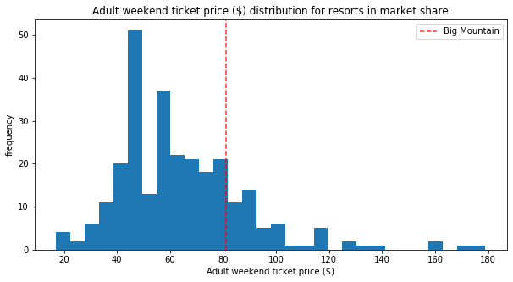

# Comparison of resources at Big Mountain with the market:

In this section, some of the most import features of ski resorts that play a key role in determining the prices are considered and plots are generated to see where Big Mountain stands among others in terms of these resources.

|  |  |
| --- | --- |
|  |  |
|  |  |

Based on these facilities available at Big Mountain, our model suggests a ticket price of**$95.87 with mean absolute error of $10.39.**

# Suggested Changes:

## **Scenario 1: Increasing revenue**

A suggestion to increase revenue is with the installation of additional chair lift and increase in vertical drop by 150 feet. Assuming 350,000 visitors per season and 5 tickets per visitor, the following estimates can be made.

$$Additional operating costs= \$1,540,000. \left(\$0.88 per ticket\right)$$

$$Projected price and revenue increase = 1.99 x 350,000 x 5 ≃ \$3,470,000 (\$1.99 per ticket)$$

$$Projected net increase in revenue= \$3,470,000 - \$1,540,000 ≃ \$1,930,000$$

## Scenario 2: Reducing cost

The following figure depicts the impact of closing runs.

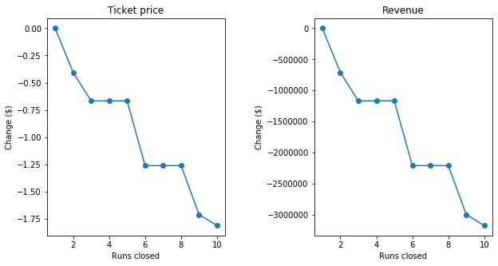

It suggests that, with a ticket price reduction of $0.66 which leads to $1,166,666 loss in revenue, Big mountain can close a maximum of 5 runs.

# Additional Data Requirements:

If the breakdown of operating costs related to different equipment, number of day and night tickets purchased, total number of visitors etc. are also available, more accurate prediction of savings and revenue increase can be done.